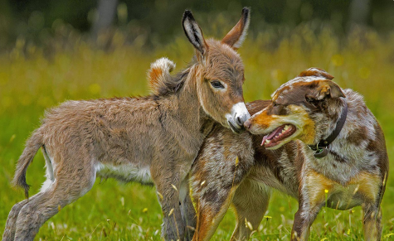
In many ways they were so different. When they stood next to each other, the stark contrast between their appearances was plain for all to see.
Appearances, however, can be deceiving. They were the best of friends….

Answer the questions below. Use the picture, writing and your imagination to help you.

What animals can you see in the picture?
____________________________________________________________________________________________________________
In what ways are these two animals different?
____________________________________________________________________________________________________________
____________________________________________________________________________________________________________
In what ways might they be similar?
____________________________________________________________________________________________________________
____________________________________________________________________________________________________________
How do you think the two animals discovered each other?
____________________________________________________________________________________________________________
____________________________________________________________________________________________________________
What do you think makes a good friend?
____________________________________________________________________________________________________________
____________________________________________________________________________________________________________
How can you show other people you are a friendly person?
____________________________________________________________________________________________________________
____________________________________________________________________________________________________________
What kind of people do you like to be friends with?
____________________________________________________________________________________________________________
____________________________________________________________________________________________________________
What kind of people do you not want to be friends with?
____________________________________________________________________________________________________________
____________________________________________________________________________________________________________

