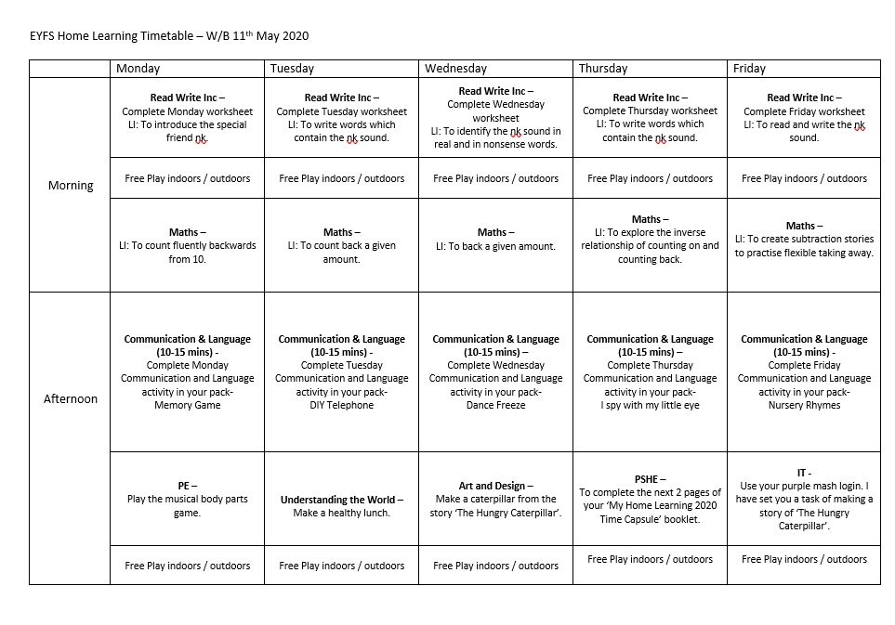

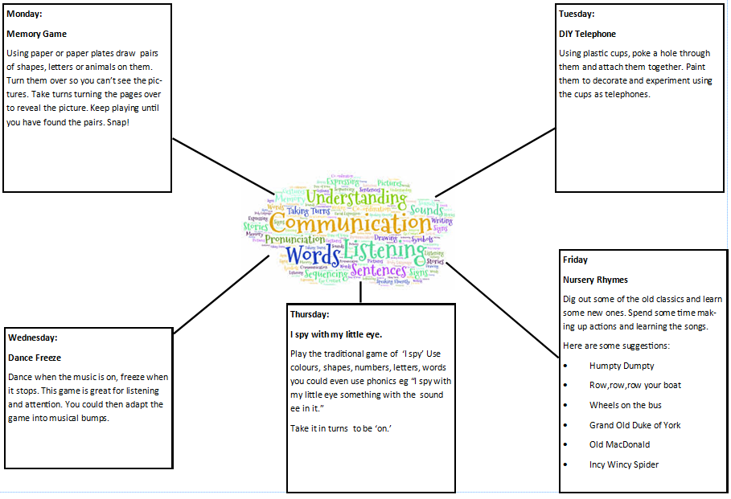

Monday 11th May 2020
Morning  activities | Read Write Inc – LI: To introduce the special friend ‘nk’.  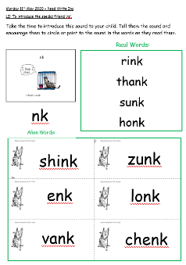  Complete Monday worksheet - Introduce the new sound ‘nk’ to your child. Tell them the sound and encourage them to circle or point to the sound in the words as they read them.
 | Free play – indoor/ outdoor
Maths – LI: To count fluently backwards from 10.
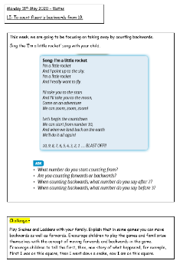
Sing the ‘I’m a little rocket’ song with your child. Play Snakes and Ladders with your child and they need to say a first, then, now story of what happened. Eg, First I was on this square, then I went down a snake, now I am on this square.

Afternoon  activities | Communication and Language – Memory Game  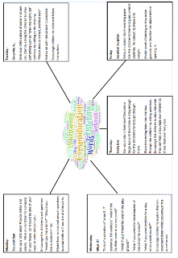  Complete Monday activity which is on the Communication and Language sheet which is included in this pack.
PE – Play the Musical Body Parts game
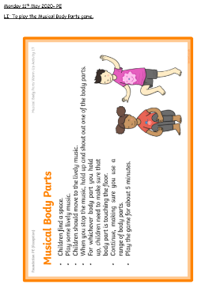
Please see the PE worksheet included in this pack for the instructions of the game.

 | Free play – indoor/ outdoor

Monday 11th May 2020 – Read Write Inc
LI: To introduce the special friend ‘nk’.
Take the time to introduce this sound to your child. Tell them the sound and encourage them to circle or point to the sound in the words as they read them.
Real Words:
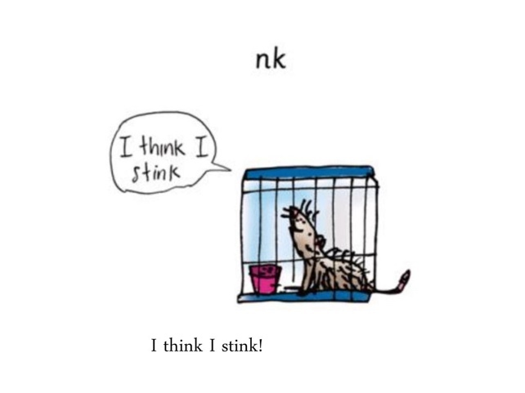
rink
thank
sunk
honk
nk

Alien Words:
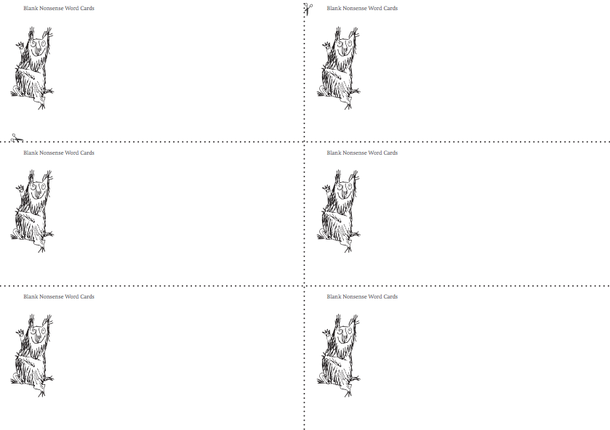
zunk
shink

lonk
enk

chenk
vank

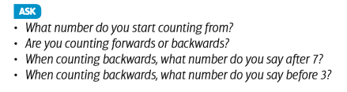
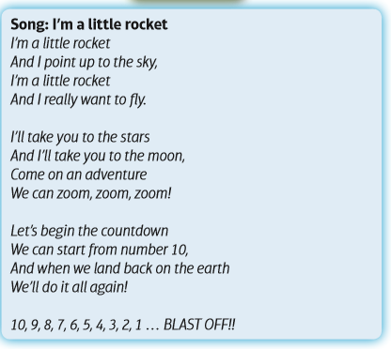
Challenge –
Play Snakes and Ladders with your family. Explain that in some games you can move backwards as well as forwards. Encourage children to play the games and familiarise themselves with the concept of moving forwards and backwards in the game. Encourage children to tell the first, then, now story of what happened, for example, First I was on this square, then I went down a snake, now I am on this square.
This week, we are going to be focusing on taking away by counting backwards.
Sing the ‘I’m a little rocket’ song with your child.

Monday 11th May 2020 – Maths
LI: To count fluently backwards from 10.

Monday 11th May 2020- PE
LI: To play the Musical Body Parts game.
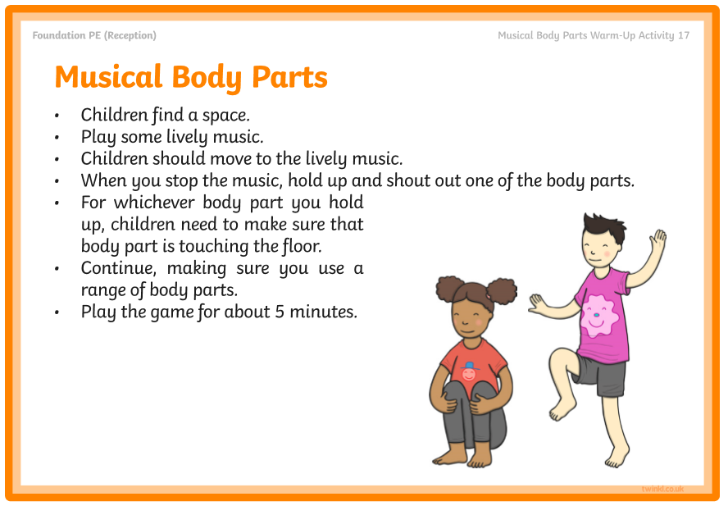

Tuesday 12th May 2020
Morning  activities | Read Write Inc – LI: To write words which contain the nk sound.  Complete Tuesday worksheet - Children are to spell and write the words for the pictures.  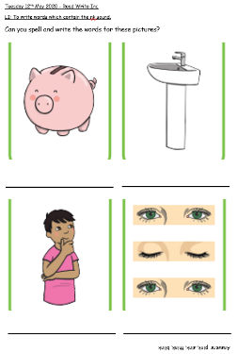
 | Free play – indoor/ outdoor
Maths – LI: To count back a given amount.
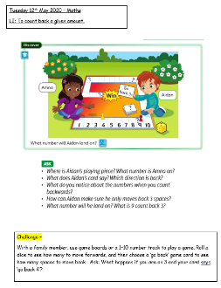
With a family member, play a board game where you are moving forwards and backwards along a track.

Afternoon  activities | Communication and Language – DIY Telephone  Complete Tuesday activity which is on the Communication and Language sheet which is included in this pack.
Understanding the World – Make a healthy lunch.
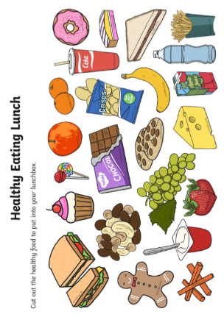
Cut out the food and stick the healthy food into the lunchbox to make a healthy lunch.
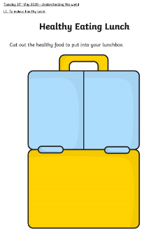

 | Free play – indoor/ outdoor

Tuesday 12th May 2020 – Read Write Inc
LI: To write words which contain the nk sound.
Can you spell and write the words for these pictures?
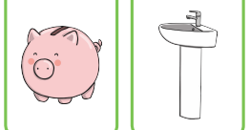

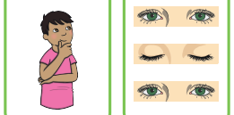
Answers: pink, sink, think, blink

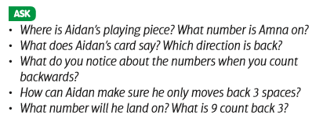
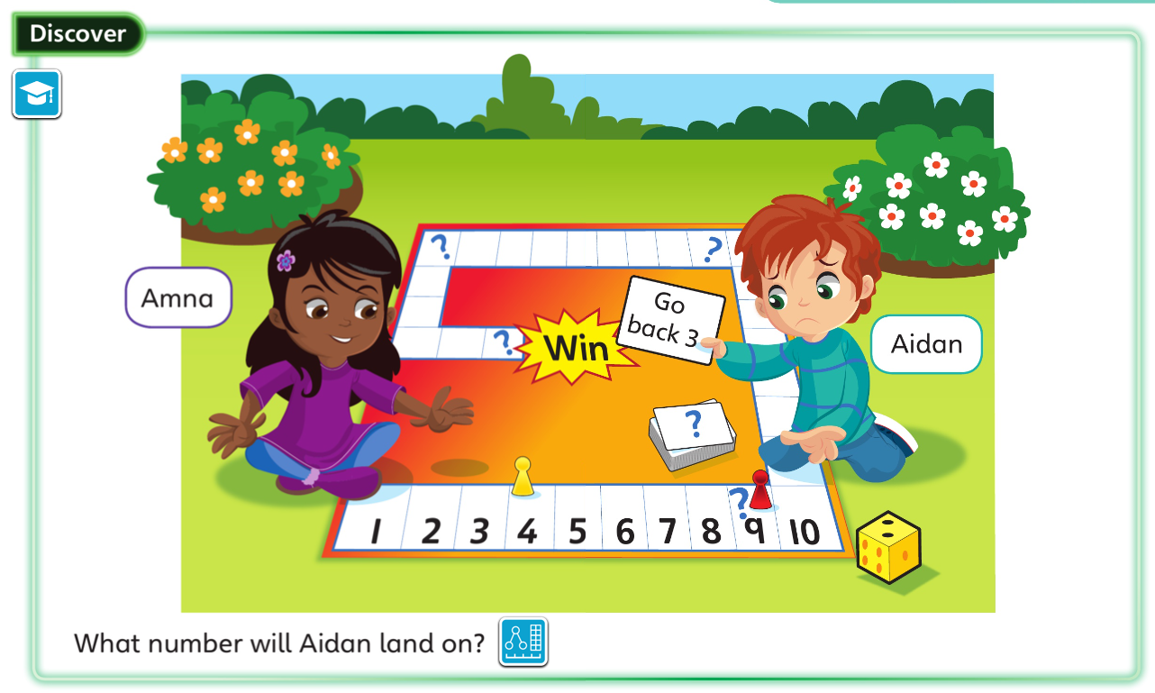
Challenge –
With a family member, use game boards or a 1–10 number track to play a game. Roll a dice to see how many to move forwards, and then choose a ‘go back’ game card to see how many spaces to move back. Ask: What happens if you are on 3 and your card says ‘go back 4’?

Tuesday 12th May 2020 – Maths
LI: To count back a given amount.

Tuesday 12th May 2020 – Understanding the world
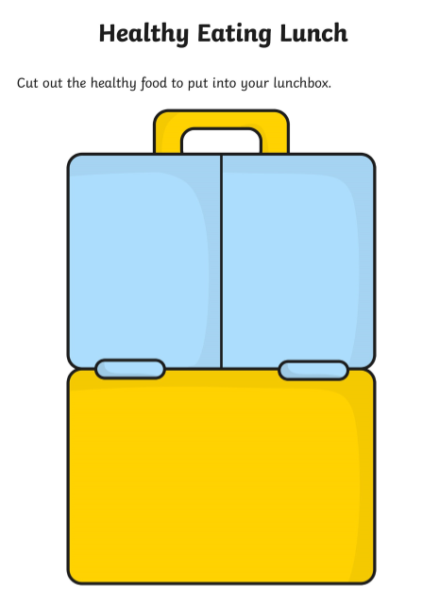
LI: To make a healthy lunch.

Wednesday 13th May 2020
Morning  activities | Read Write Inc – LI: To identify the nk sound in real and nonsense words.  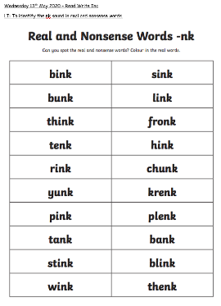  Complete Wednesday worksheet – colour in the real words which contain the nk sound.
 | Free play – indoor/ outdoor
Maths – LI: To count back a given amount.
Children are to complete Page 8 in their Power Maths Journals.
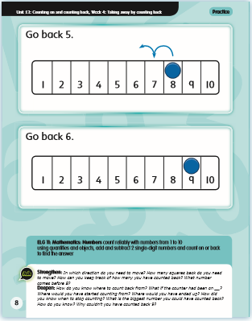

Afternoon  activities | Communication and Language – Dance Freeze  Complete Wednesday activity which is on the Communication and Language sheet which is included in this pack.
Art and Design – To make a caterpillar from the story ‘The Hungry Caterpillar’.
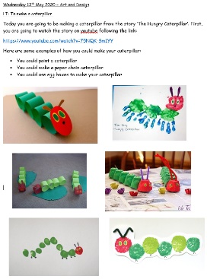
Make your own caterpillar using paint, paper chains or egg boxes. Please see the worksheet included in this pack for ideas.

 | Free play – indoor/ outdoor

Wednesday 13th May 2020 – Read Write Inc
LI: To identify the nk sound in real and nonsense words.
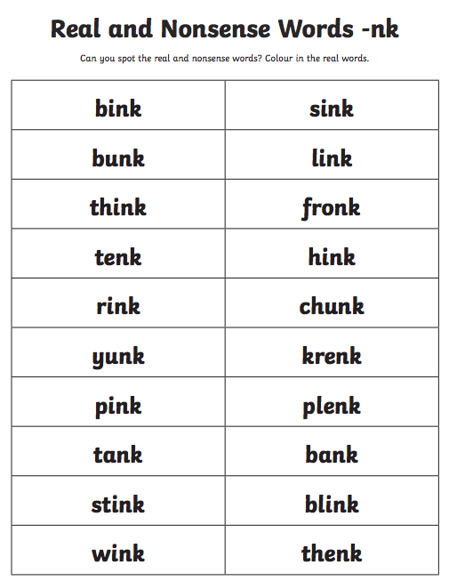

Today, children will complete page 8 in their Power Maths Journal.
This activity gives children the opportunity to consolidate the skill of counting back using a number track. The first part models how to draw the jumps to support children in drawing them to find the answer. In the second part, children might want to draw the jumps or use a counter or a finger to move back along the number track.

Wednesday 13th May 2020 – Maths
LI: To count back a given amount.

Wednesday 13th May 2020 – Art and Design
LI: To make a caterpillar.
Today you are going to be making a caterpillar from the story ‘The Hungry Caterpillar’. First, you are going to watch the story on youtube following the link:
https://www.youtube.com/watch?v=75NQK-Sm1YY
Here are some examples of how you could make your caterpillar:
- You could paint a caterpillar
- You could make a paper chain caterpillar
- You could use egg boxes to make your caterpillar

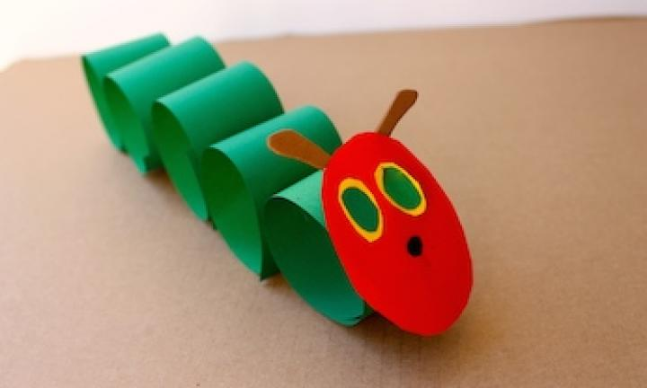
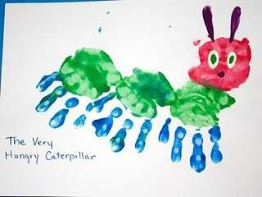
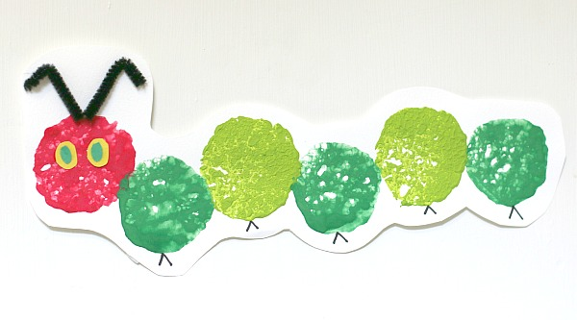
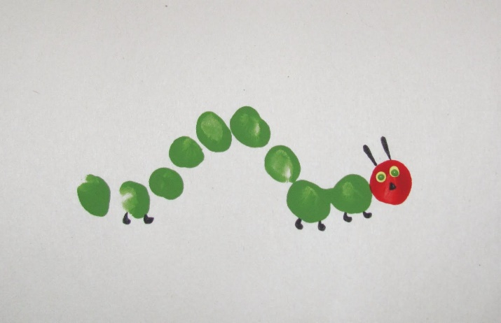
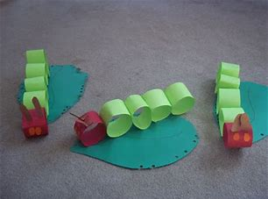
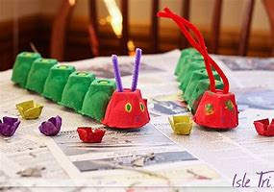

Thursday 14th May 2020
Morning  activities | Read Write Inc – LI: To write words which include the nk sound.  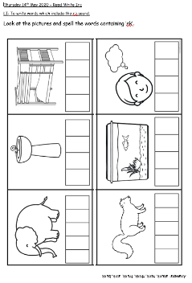  Complete Thursday worksheet – Look at the pictures and spell the words containing nk.
 | Free play – indoor/ outdoor
Maths – LI: To explore the inverse relationship of counting on and counting back.
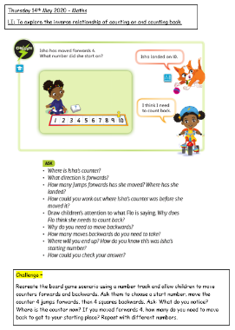
Recreate a board game scenario using a number track and allow children to move counters forwards and backwards.

Afternoon  activities | Communication and Language – I spy with my little eye.  Complete Thursday activity which is on the Communication and Language sheet which is included in this pack.
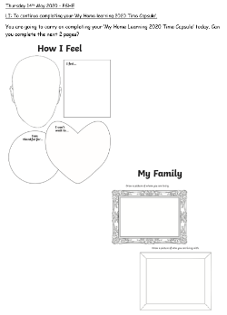
PSHE – To continue completing your ‘My Home Learning 2020 Time Capsule’ booklet.
Complete the next 2 pages in your booklet.

 | Free play – indoor/ outdoor

Thursday 14th May 2020 – Read Write Inc
LI: To write words which include the nk sound.
Look at the pictures and spell the words containing ‘nk’.

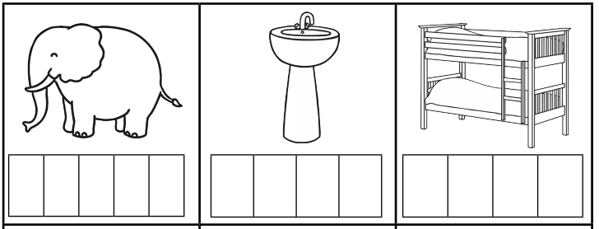
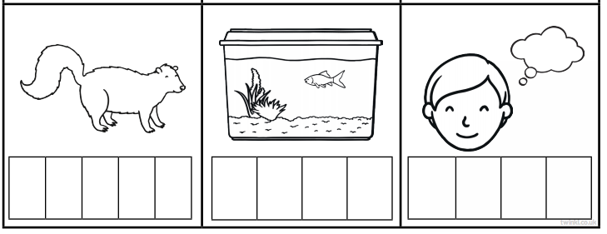
Answers: skunk, tank, think, trunk, sink, bunk

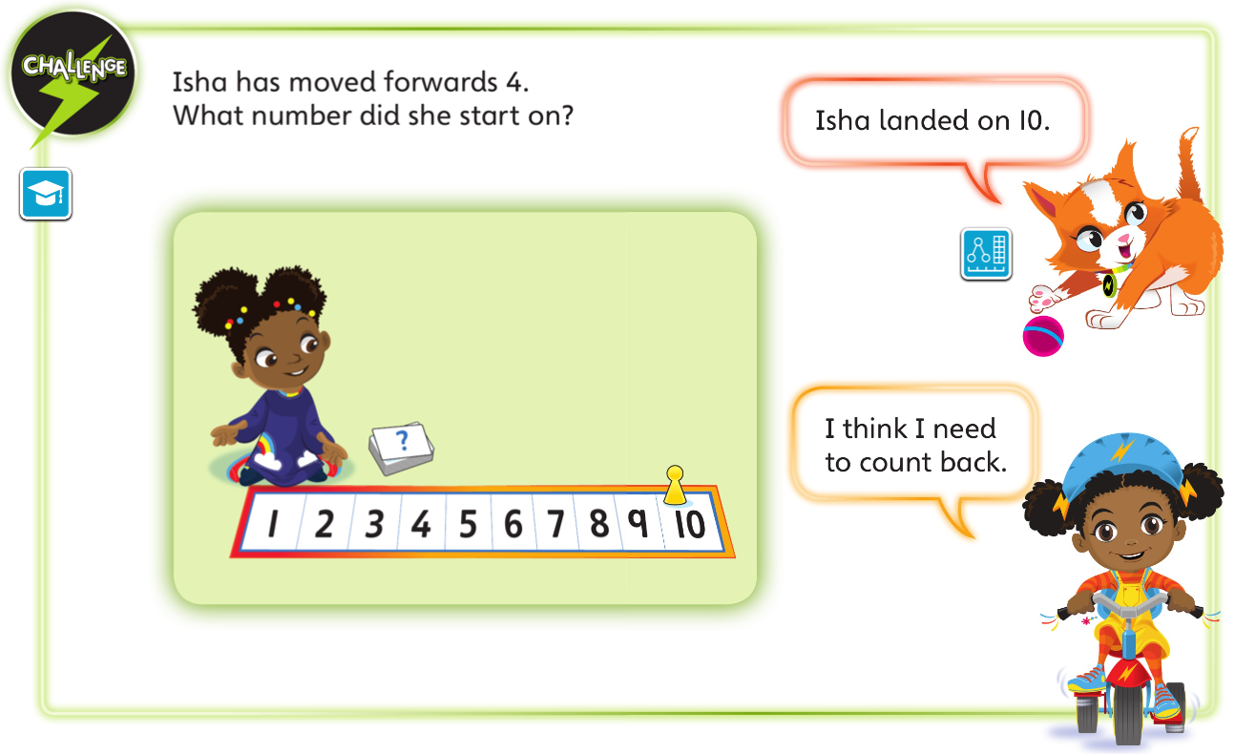
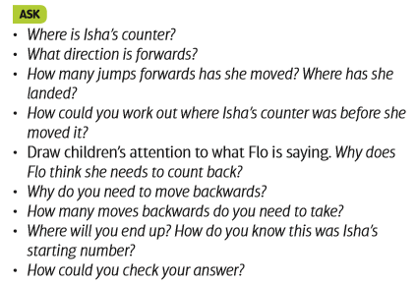
Challenge –
Recreate the board game scenario using a number track and allow children to move counters forwards and backwards. Ask them to choose a start number, move the counter 4 jumps forwards, then 4 squares backwards. Ask: What do you notice? Where is the counter now? If you moved forwards 4, how many do you need to move back to get to your starting place? Repeat with different numbers.
Thursday 14th May 2020 – Maths
LI: To explore the inverse relationship of counting on and counting back.

Thursday 14th May 2020 – PSHE
LI: To continue completing your ‘My Home learning 2020 Time Capsule’.
You are going to carry on completing your ‘My Home Learning 2020 Time Capsule’ today. Can you complete the next 2 pages?
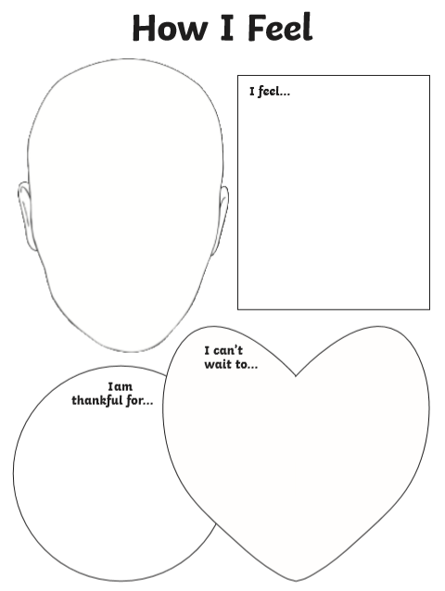

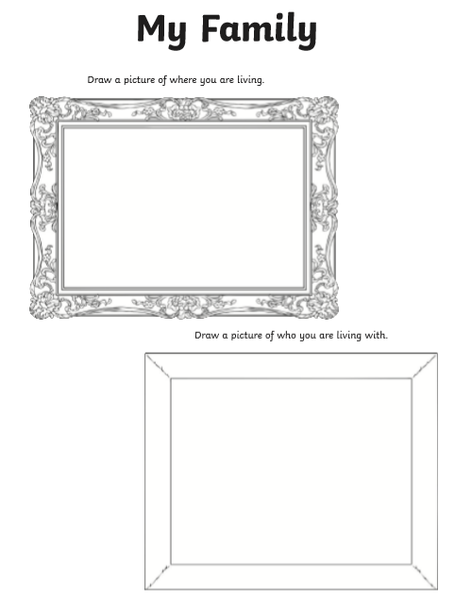

Friday 15th May 2020
Morning  activities | Read Write Inc – LI: To read and write the nk sound.  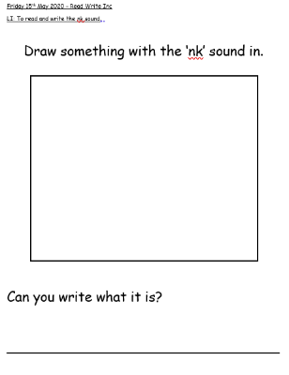  Complete Friday worksheet – Draw and write something that has the nk sound in it.
 | Free play – indoor/ outdoor
Maths – LI: To create subtraction stories to practise flexible taking away.
Children are to complete Page 9 in their Power Maths Journals.
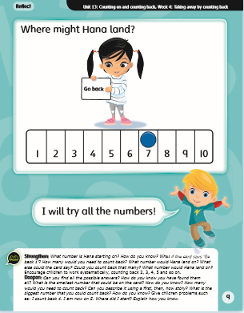

Afternoon  activities | Communication and Language – Nursery Rhymes  Complete Friday activity which is on the Communication and Language sheet which is included in this pack.
IT – Purple Mash
I have set you a task on Purple Mash to make a story using scenes from ‘The Hungry Caterpillar’.

 | Free play – indoor/ outdoor

Friday 15th May 2020 – Read Write Inc
LI: To read and write the nk sound.

Draw something with the ‘nk’ sound in.

Can you write what it is?

________________________________

Today, children will complete page 9 in their Power Maths Journal.
This activity gives children the opportunity to consolidate the skills they have learnt and incorporates an element of problem solving. Children use a number track to count backwards, finding all the possibilities for how many Hana could move back.

Friday 15th May 2020 – Maths
LI: To create subtraction stories to practise flexible taking away.

