Week of 4th May 2020 – Art

Andy Goldsworthy –is a British artist known for his site-specific installations involving natural materials and the passage of time. Working as both sculptor and photographer, Goldsworthy crafts his installations out of rocks, ice, leaves, or branches, cognizant that the landscape will change, then carefully documents the ephemeral collaborations with nature through photography.

This week’s afternoon activities are to create pieces of art work inspired by Andy Goldsworthy. He uses things that you would find in nature to create hi pictures and sculptures. I have put together pictures of his and that children have done.

Task 1 – to research Andy Goldworthy and make a fact file. (Paper included)
Task 2 – draw your favourite piece of his work one you have found or one that I have put in.
Task 3 – create a piece of art using natural objects (you can colour/ paint’ chalk them if you need) take a picture and add it to the blog.
Task 4 – use a different type of material and make another.
Task 5 – Draw using a different type of material maybe try using mud and a stick on stone or on paper or draw on stone with a stone.
Task 6 – have fun!

This is supposed to be fun and relaxing you may need to pick up natural items up on your walk but don’t forget to be safe and wash your hand when you finish. You can do this with your siblings or adults as a group project. I would LOVE to see some of your work that you create please email them or comment with a picture on the blog let’s see if we can get enough pictures that we could make a collage to send out with the newsletter.

Use this page to create a fact file about him.
__________________________________________________________
__________________________________________________________
__________________________________________________________
__________________________________________________________
__________________________________________________________
__________________________________________________________
__________________________________________________________
__________________________________________________________
__________________________________________________________
__________________________________________________________
__________________________________________________________
__________________________________________________________
__________________________________________________________
__________________________________________________________
__________________________________________________________
__________________________________________________________
__________________________________________________________
__________________________________________________________
__________________________________________________________
__________________________________________________________
__________________________________________________________
__________________________________________________________
__________________________________________________________
__________________________________________________________
__________________________________________________________
__________________________________________________________
__________________________________________________________
__________________________________________________________
__________________________________________________________
Andy Goldsworthys art work.
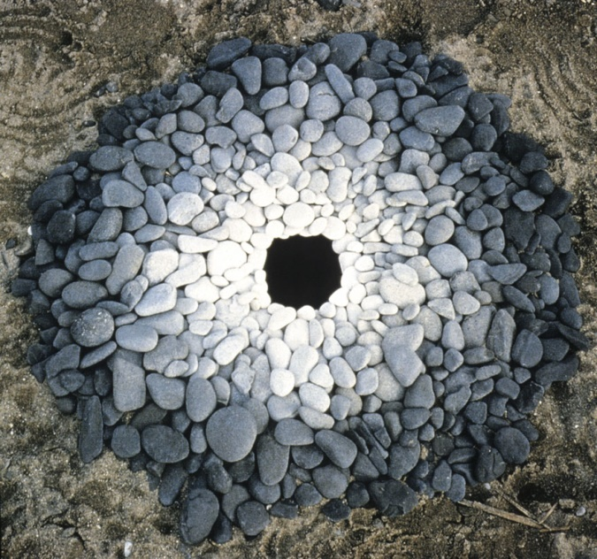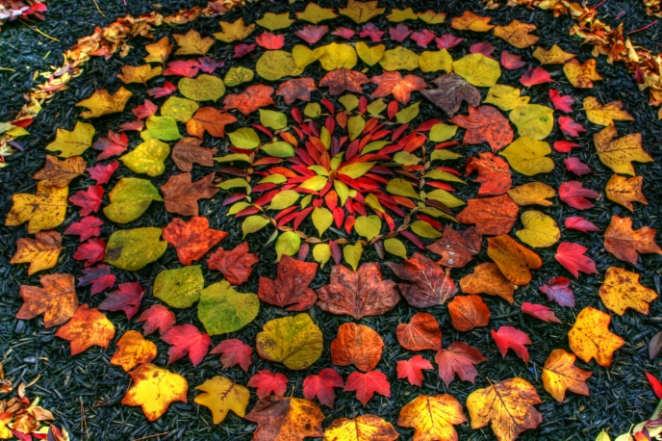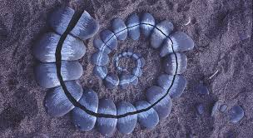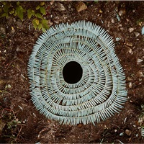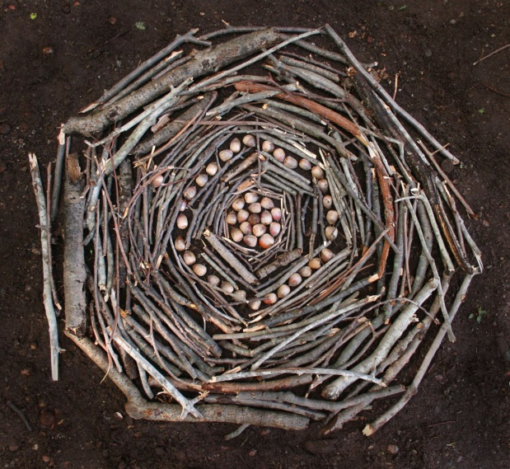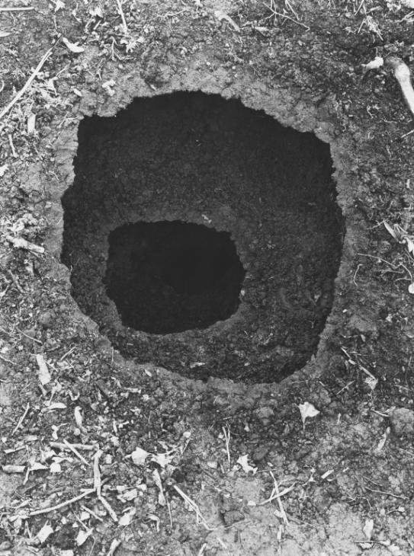

Art work by children inspired by Andy Goldsworthy
