My Diary
of a __________

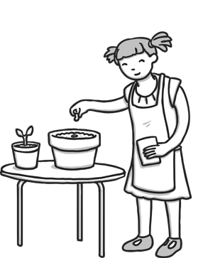
Equipment What Do Plants Need?
Things plants need to grow:

Instructions
Cut out the pictures on the last page and stick them in the right order to show how to plant a seed.

My Flower: Week 1
Instructions Pictures
Cut out these pictures and stick them in the right order, on the instructions page, to show how to plant a seed.

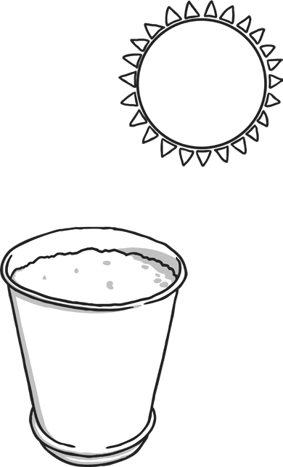
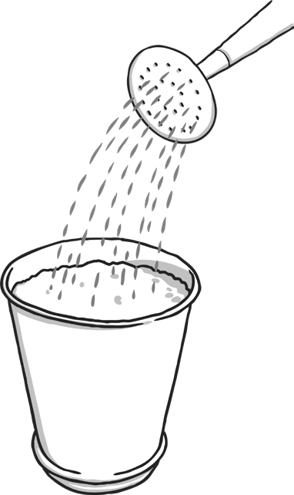
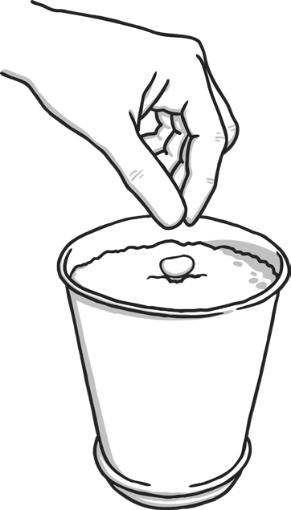

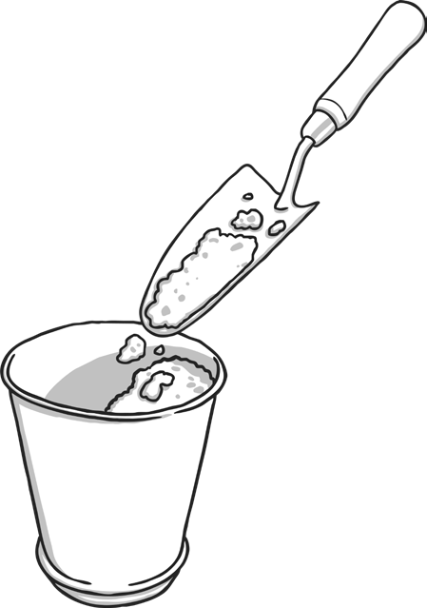
My flower is cm tall.

My flower is cm tall. My flower is cm tall.

My flower is cm tall. My flower is cm tall.

